The original graph is shown

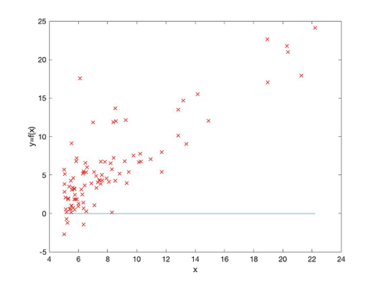

After add

> theta_0 = theta(1);

> theta_1 = theta(2);

> hypothesis =X(training_example,1) * theta_0 + theta_1 * X(training_example, 2);

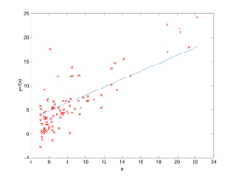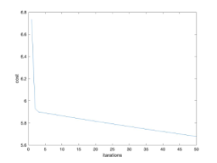

Change

> theta = [1.0, 5.0];

2.

Origin like this

After Add

> theta_0 = theta(1);

> theta_1 = theta(2);

> theta_2 = theta(3);

> hypothesis =1 * theta_0 + theta_1 * X(training_example, 1) + theta_2 * X(training_example, 2);

In calculate_hypothesis.m file

And change

From

> hypothesis = X(i, 1) * theta(1) + X(i, 2) * theta(2);

To

> hypothesis = 1 * theta(1) + X(i, 1) * theta(2) + X(i, 2) * theta(3);

%update theta

> theta = [theta_0, theta_1, theta_2];

> for i = 1:m

> hypothesis = 1 * theta(1) + X(i, 1) * theta(2) + X(i, 2) * theta(3);

> output = y(i);

> sigma = sigma + (hypothesis - output) * X(i, 2);

> end

> theta_2 = theta_2 - ((alpha * 1.0) / m) * sigma;

In gradient_descent.m file

And change theta value

> theta = [1.0, 5.0, 5.0];

> alpha = 0.7;

2.2

Add

> Xpredict = [1630,3];

> Xnorm = (Xpredict - mean_vec)./std_vec;

> Xnorm = [1,Xnorm];

> Ypredict = sum(Xnorm .* theta);

> disp(Ypredict);

1650 3

2.9365e+05

3000 4

4.7261e+05

1. hypothesis =(X(training_example, 1)) * theta(1) + theta(2) * (X(training_example, 2))^1 + theta(3) * (X(training_example, 3))^2+ theta(4) * (X(training_example, 4))^3+ theta(5) * (X(training_example, 5))^4+ theta(6) * (X(training_example, 6)^5);

theta =

0.4426 -0.4069 -0.3969 -1.2837 -1.2005 -1.8102

3 -2

1. l = 0.1;

j > 0

1. theta(2) = theta(2)*(1 - alpha*l/m) - ((alpha * 1.0) / m) * sigma;

3-3

1. alpha = 0.3;